Islanding Operation and Autonomous Power Management for Interconnected AC/DC Microgrids

Dileep Prudhvi Yeddula  
Electrical and Electronics Engineering

Raghu Engineering College

Visakhapatnam, India

[19985A0298@raghuenggcollege.in](mailto:19985A0298@raghuenggcollege.in)

Srinivas Palacherla Assistant professor  
Electrical and Electronics Engineering

Raghu Engineering College

Visakhapatnam, India

[srinivas.palacherla@raghuenggcollege.in](mailto:srinivas.palacherla@raghuenggcollege.in) Sai Ganesh Thummuri  
Electrical and Electronics Engineering

Raghu Engineering College

Visakhapatnam, India

[19985A290@raghuenggcollege.in](mailto:19985A290@raghuenggcollege.in)

Anjali Mandala  
Electrical and Electronics Engineering

Raghu Engineering College

Visakhapatnam, India

[19985A0242@raghuenggcollege.in](mailto:19985A0242@raghuenggcollege.in)

Divakar Kola  
Electrical and Electronics Engineering

Raghu Engineering College

Visakhapatnam, India

[19985A0231@raghuenggcollege.in](mailto:19985A0231@raghuenggcollege.in)

***Abstract* - Due to many operational flaws in existing power management techniques for interconnected AC-DC microgrids, which are either concerned with simply sharing power or voltage regulation but not both, this study is recommended to address these concerns. Before importing electricity from the interconnected AC microgrid, this suggested autonomous power management strategy will assess the specific loading situation of the DC microgrid. This method not only allows for DC microgrid voltage management, but it also minimizes the number of converters in use, which lowers power transmission losses. The suggested concept is completely self-contained, as it includes plug-and-play generators and tie-converters. The suggested control scheme's performance has been verified under a variety of conditions. Because the generators and tie-converters are plug-and-play, the suggested concept is completely self-governing. The proposed control scheme's performance has been verified in a variety of scenarios. The results show that the suggested approach is effective in handling power shortages in DC microgrids efficiently and autonomously while maintaining better DC microgrid voltage regulation. A DG interfacing network, as well as its control, will be simulated in this study to assess system stability. The MATLAB/SIMULINK environment is used to verify the results.**

***Keywords—Introduction, control strategy, proposed hybrid control scheme, DG Interfacing system, MATLAB simulation and Results, Conclusion, References***

**I. Introduction**

The development of power electronics plays a key role in the deployment of renewable and alternative energy technologies, which have been widely implemented in various network topologies and configurations to date. They've also been supervised and controlled using a variety of control techniques and architectures. Their network topologies and control mechanisms have mostly been settled to optimize benefits while satisfying load needs. Renewable and alternative energy technologies are widely used in microgrids nowadays. The distribution of these new technologies via a microgrid is chosen because it offers various benefits, including better resource utilization, greater power quality, and increased supply reliability. Advanced Grid features have been combined with zone-based grid features in recent years. Interconnected AC-DC microgrids, interconnected AC-AC microgrids, and multi microgrids are the three types. The main goal was to get the most out of renewable and alternative energy sources. Interconnection of two or more microgrids, for example, will allow reserve sharing, support voltage and frequency, and, in the end, increase the overall dependability and resilience of interconnected microgrids. The interconnection of two or more microgrids has been made based on the overall objectives, control, and management techniques.

The microgrids can be linked directly or through a tie converter that harmonizes them. Harmonized tie converters are typically employed when two or more microgrids have different operating voltages and frequencies. Tie converters are required if the microgrids to be interconnected have different control techniques and the power flow between them needs to be managed. Similarly, tie converters are required for interconnecting a DC microgrid with a utility grid or another AC grid, as well as regulating power flow, among other functions, and have been investigated under various scenarios in the published literature for the interconnection of tie-converters of AC-DC microgrids, and demand droop control has been proposed. The normalized terminal voltage and frequency of the droop controlled interconnected AC-DC microgrids are used to determine the power flow action. Based on relative loading conditions, this technique allows autonomous power transfer between two interconnected microgrids. If the power flow decision is made based on relative loading, the interlinking converter will function continuously, resulting in unavoidable operational losses. By providing a storage system, the same power-sharing technique has been extended to interconnected microgrids. This technique is further enhanced by progressive auto-tuning, which reduces the amount of energy that flows through interlinking converters. The suggested auto-tuning technique only allows power transmission when one microgrid is significantly loaded and the other is lightly loaded. This droop-based power-sharing has been researched for various operating situations of interconnected AC and DC microgrids. This power management technique for a three-port system with AC, DC, and a storage network is presented in. The power-sharing decision is made based on the loading condition - Until now, all decentralized power-sharing solutions for interconnected AC-DC microgrids that have been published have relied solely on the droop principle or voltage regulation. In contrast, voltage regulation schemes regulate only the voltage of the DC microgrid, ignoring the specific loading conditions of the generators, and tie-converters do not have a plug-and-play feature.

These flaws and disadvantages can be addressed explicitly by implementing the recommended control mechanism in this project. The suggested autonomous power management method for interconnected AC-DC microgrids transfers electricity from the AC to the DC microgrid during peak load demand while taking into account the generators' individual loading conditions and also regulating the DC microgrid’s voltage. The suggested system allows tie converters to be plug-and-play, while simultaneously reducing the number of converters in use to avoid unnecessary losses. The DC grid has insufficient generation capacity in the proposed scenario due to excessive load variability and high and low renewable energy supply. The AC microgrid is deemed suitable if it has controlled voltage and frequency, as well as enough surplus power to transfer to the DC microgrid during peak demand or a crisis situation. A hybrid droop and voltage regulation mode control for tie-converters in interconnected AC-DC microgrids have been developed to achieve the attributes stated above.

To assess the overall loading status of the droop-controlled DC microgrid, the proposed control technique uses the terminal voltage information of the tie converter. During the day, the tie-converter automatically activates and transmits power to the DC microgrid. The voltage of the DC microgrid is regulated at a set nominal level using the proposed hybrid control technique. Furthermore, the suggested scheme permits multiple tie-converters to be interfaced, in contrast to the existing scheme, which allows all tie-converters to run simultaneously regardless of the power transfer demand. When the first converter's power capacity is reached, the succeeding tie-converter is only activated once. The proposed scheme is self-contained and has enhanced features.

**II. CONTROL STRATEGY**

As illustrated in Fig.2.1, the considered DC microgrid includes both non-dispatchable (solar-PV) and dispatchable generators (microturbine, fuel-cell) additionally to loads. However, because it's set to run in current control mode, the non-dispatchable solar PV system pulls maximum power the smallest amount bit times. The dispatchable generators are usually used for stabilizing renewable capacity and are controlled via a centralized or decentralized control method. The decentralized droop system is that the most generally used and favored method due to its simplicity and reliability. As a result, for the dispatchable generators of the DC microgrid (see Fig.2.1), the standard droop (P-V)scheme has been utilized, which is provided by

Vdc ,ref ,i =Vdc ,max -∂dc ,i P dc ,i

∂dc ,i = = (1)

where I is that the amount of the DC generator I = 1, 2, 3, etc. ); That is the generator's reference voltage vdc,ref; Pdc denotes the generator's output power. (V dc, min= Vdc, nom, TC1) and (V dc, max= Vdc, nom, TC1)are the defined maximum and minimum voltages; Pdc, max, is that the utmost or rated power of ith generator; and dc, i is that the droop gain of (2) and (3) are often accustomed calculate the voltage reference for the droop regulated generators 1 and a pair of. (3). Because generators 1 and a pair of share the identical DC bus voltage (Vdc, ref,1 = Vdc, ref,2), (2) and (3) could even be equal and translated as (4), demonstrating that droop-controlled generator power-sharing is proportionate to their rated capacity.

Vdc,ref,1 =Vdc ,max -∂dc,1Pdc,1 (2)

Vdc,ref,2 =Vdc ,max -∂dc,2Pdc,2 (3)

∂dc,1Pdc,1 =∂dc,2Pdc,2 → = = (4)

The terminals on the generator are identical. Because all of the generators are connected by feeders and cables of varying lengths, the voltage at each generator terminal isn't identical. Because the voltage mismatch at the generator terminals affects power-sharing, it must be adjusted using any of the appropriate compensation methods. The droop equation with feeder voltage-drop compensation is simplified as

Vdc,ref,i =vdc,max -∂dc,i P dc,i +I dc,i Xi (5)

The droop-controlled DC microgrid’s voltage will change when the load changes, but only within the stated permitted range. The voltage range with increased aggregated loading for the studied DC microgrid is displayed in Fig.2.1. (bottom left). The voltage range I for droop regulated generators is about between 395 and 420 volts, suggesting that at 420 volts, the generators will deliver no power and at 395 volts, 100 pc power. The tie-converters will start importing power from the AC microgrid to fulfil the peak load demand on the DC system as soon because the DC generators are heavily loaded (e.g., 402.5 V at 80% generator loading).

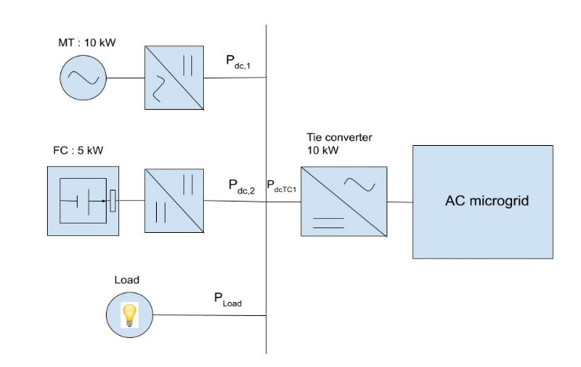

Fig.1:Block diagram of AC/DC Microgrid

As a result, we may control the voltage of the DC microgrid by employing tie converters. as an example, within the interconnected microgrids depicted in Fig.2.1, the AC microgrid's voltage and frequency are considered stiff. The AC microgrid are operated in grid-connected mode or droop regulated with secondary voltage and frequency regulation.

Furthermore, the AC microgrid has sufficient generation capacity to fulfil local demand and is additionally capable of exporting excess power to the DC microgrid, as seen by the proposed autonomous control of tie-converters. The control of tie-converters is detailed in Section.

**III. PROPOSED HYBRID CONTROL**

The variability of the renewable source and loads in the microgrid will decide the power rating of the dispatchable generators or storage system so as to stabilize the renewable capacity. The high-power rating dispatchable generators or storage systems are required for highly variable renewables and loads, which may or may not be a viable solution. Alternatively, the microgrid with inadequate generation capacity can be interconnected with another microgrid or utility grid, directly or through harmonizing converters. The tie converter is the only way possible to interconnect the DC microgrid to the AC microgrid. In the proposed interlinked system, the AC microgrid is specified as a regulated voltage and frequency system with adequate generation capacity, whereas the DC microgrid is specified as a droop-controlled system with inadequate generation because of the high variability of the renewable and loads.

Because of the high variability of renewables and loads, the AC microgrid is specified as a regulated voltage and frequency system with adequate generation capacity, whereas the DC microgrid is specified as a droop-controlled system with inadequate generation capacity in the proposed interconnected system. The power deficit in the DC microgrid is handled by importing power from the AC microgrid when peak demand or low renewable power supply occurs. It should be possible to achieve this using the proposed tie-converter control. In essence, the tie-converter control strategy was created with the following objectives in mind:

1) To transfer power from the AC to the DC microgrid when there is a contingency in the DC microgrid or a peak demand requirement

2) To reduce power transfer losses by reducing the number of tie converters in operation based on the power transfer demand, for example, a tie converter should only operate during peak load demand.

3) To regulate the droop-controlled DC microgrid's voltage

4) To accomplish fully autonomous control that is not dependent on the communication network

5) To allow tie converters and generators to be plug-and-play.

For tie-converters, a hybrid droop and voltage regulation mode control are proposed instead of the existing approaches for interconnected AC-DC microgrids, and the algebraic form of the proposed control scheme is given by

Vdc ,ref ,TC x =

Off;

Vdc ,start ,TC x - ᵟL ,TC x × P dc ,TC x;

Vdc ,nom ,TC x;

Vdc ,nom ,TC x-ᵟH ,TC x[P dc ,TC x-(100-H)%×P dc ,max ,TC x];

Instead of existing techniques for interconnected AC-DC microgrids, a hybrid droop and voltage regulation mode control for tie-converters is presented, with the mathematical form as follows: where TCx indicates the tie-converter number (x = 1, 2, 3..); Vdc is the DC microgrid voltage; Vdc, ref, TCx is the xth tie-reference converter's voltage; Vdc, start, TCx is the threshold voltage for the xth tie-converter to start; Vdc, nom, TCx is the nominal voltage to be regulated by the xth tie-converter; Pdc, TCx is the DC power output of the xth tie-converter; Pdc, max, TCx is the maximum power limit of the xth tie-converter; L percent and H percent are the percentages of tie-converter power should be rated in the location of droop-1 and droop-2 modes respectively. At the set condition, Pdc,TCx> L percent Pdc, max, TCx, the tie-converter starts in the droop control mode and smoothly transitions to the voltage regulation mode. The tie converter imports electricity from an AC microgrid to a DC microgrid to meet peak load demand while also regulating its voltage to the nominal value of Vdc, nom, TCx, which is referred to as voltage regulation mode. Furthermore, the operation of the converters has been prioritized, as opposed to the conventional schemes' parallel functioning of tie converters. When all of the generators in the DC microgrid are heavily loaded, the first tie-converter kicks in. As the first tie-power converter's capacity approaches saturation at Pdc, TCx= (100 - H) percent Pdc, max, TCx, its control mode is switched from voltage regulation to droop 2 control mode, allowing minimal voltage drop. The next tie converter will use the slight voltage drop induced by droop 2 control to commence its function. If the first tie-converter fails to operate, the second tie-converter will automatically operate, causing a voltage drop due to the high load demand. As a result, the suggested control method assures efficient and reliable operation under all operating situations without sacrificing the inherited flexibility of the droop-based system. The power allocation of the tie-converter for droop1 and droop 2 control modes is determined by the user-definable L percent and H percent, and should be tuned to allow for a smooth transition between modes while taking into account the voltage and power measurement tolerance or errors in the microgrid under consideration. By deploying the proposed voltage regulation mode, the DC microgrid's overall voltage regulation performance can be improved.

Vdc > Vdc ,start ,TC x

0≤Pdc,TCx≤L%×P dc ,max ,TC x

L%×P dc ,max ,TC x<P dc ,TC x <(100-H)%×P dc ,max ,TC x

(100-H)%×P dc ,max ,TC x ≤P dc ,TC x ≤P dc, max ,TC x

The voltage of the DC microgrid is managed at the nominal value during peak load demand, which is not done with existing power management systems for interconnected microgrids. The suggested scheme's performance has been verified for various load operating conditions, as indicated.

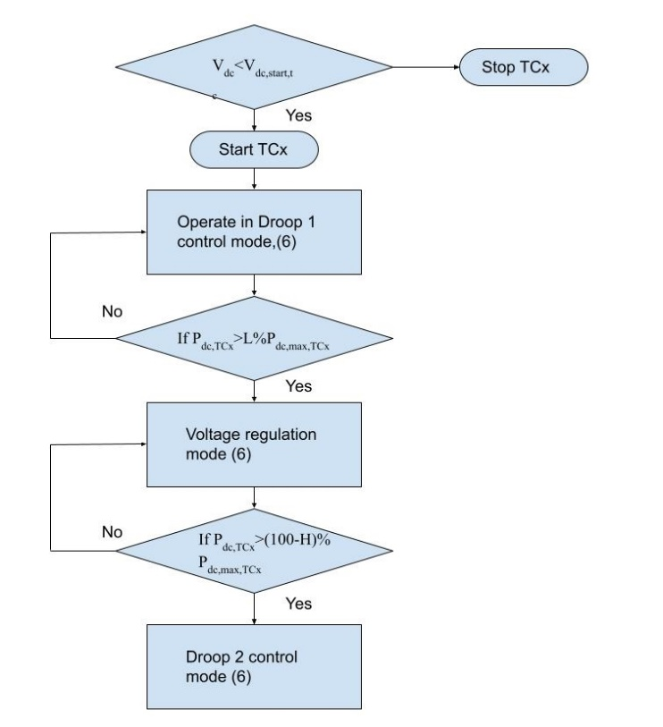

Fig. 3.1: Logic flow diagram showing mode transitions of tie-converter

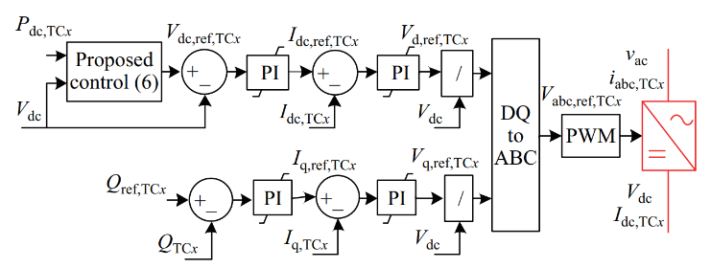

Fig. 3.2: Control block diagram of tie-converter.

**IV. DG INTERFACING SYSTEM DESCRIPTION**

Figure 4 depicts the recommended test system for islanding detection research, which includes an inverter-based DG, a parallel RLC load, and a grid represented by a source behind impedance. The DG's operation mode is determined by whether the circuit breaker is closed or not. The maximum power point tracking controller is typically used with inverter-based DG such as photovoltaic and wind power generation. The output power can be deemed constant during the detection due to the very short islanding detection period.

A continuous dc source is used behind a three-phase inverter because the DG is designed as a constant power source. The block diagram of the DG interface control is shown in Figure 5. The Phase-Locked Loop (PLL), the outside power control loop, and the inner current control loop are the three main components. The DG can manage the active and reactive power output separately based on the dual close loop control structure in the d-q synchronous reference frame, according to the instantaneous power theory and the Park transformation.

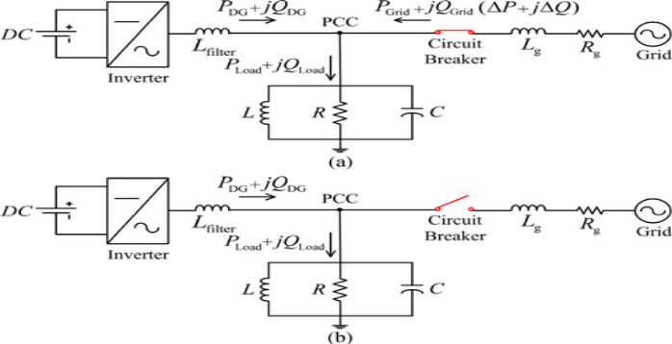

Fig. 4.1: Test system for islanding detection study

(a) Grid-connected operation mode

(b) Islanding operation mode.

The power flows and active and reactive power required by the load are described by the equations below when the DG is linked to the utility grid, as shown

P load = P DG +P Grid =

Q load = QDG +Q Grid =3V_PCC^2 (1/2πfL-2πf C)

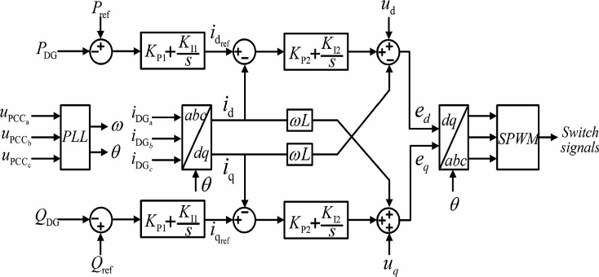

Fig. 4.2: DG interface control for constant power operation.

**V. MATLAB SIMULATION**

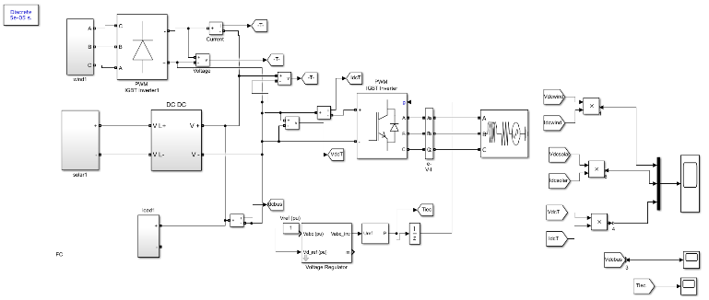

Fig.5.1: DC microgrid with microturbine, fuel cell and load.

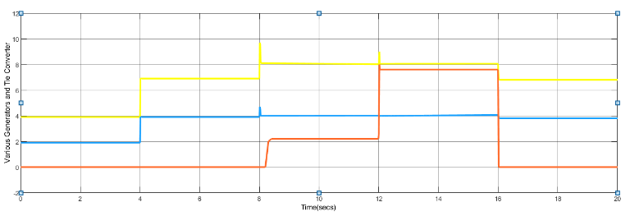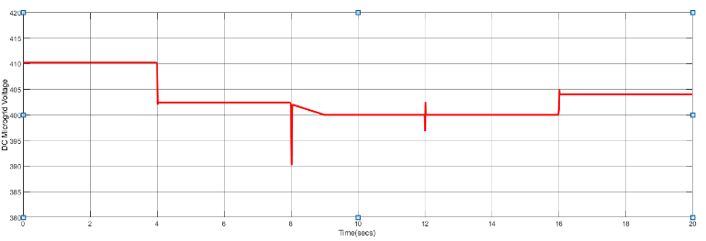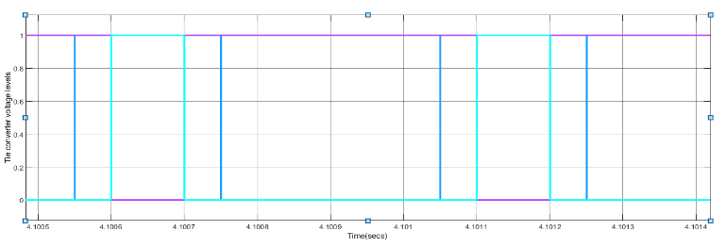

Fig. 5.2: Results showing (a) generators and tie-converter power, (b) DC microgrid voltage and (c) tie-converter control signals for four different load operating conditions.

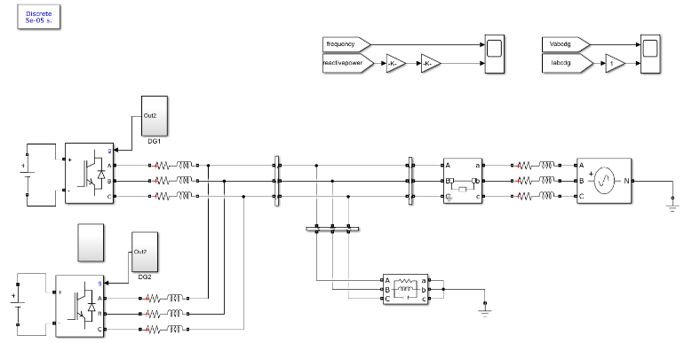

Fig. 5.3 Overall Configuration of the Islanding Detection Method

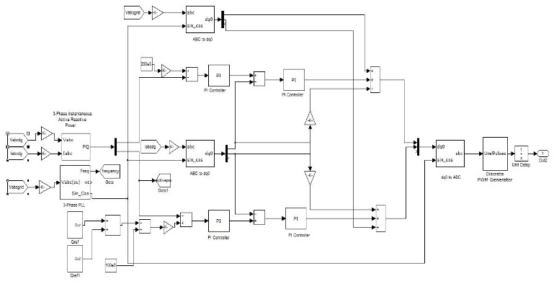Fig 5.4 The block diagram of the DG interface control

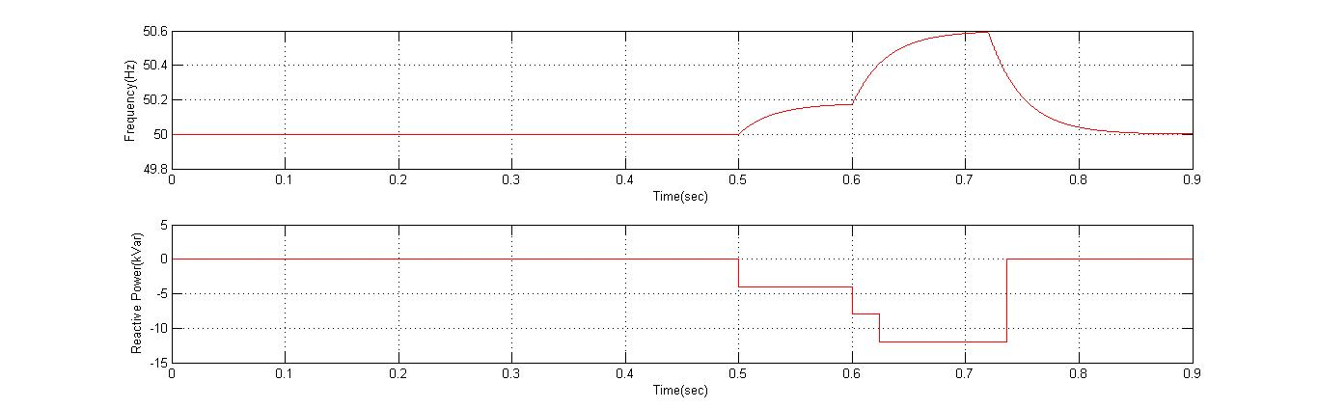

Fig 5.5 shows Reactive power and frequency vs time in sec

**VI. CONCLUSION**

For interconnected AC-DC microgrids with various designs, an autonomous power management strategy has been provided. The suggested approach efficiently and autonomously regulates the power shortage in the DC microgrid. To avoid excessive operating losses, the recommended prioritization has reduced the number of tie-converters in use. To investigate system stability, a DG interfacing network and its control must also be modelled. In the DC microgrid, the method has shown greater voltage regulation. The suggested scheme's performance and robustness were tested in two separate DC microgrid situations with varying load conditions.

**REFERENCES**

[1] J. Rocabert, A. Luna, F. Blaabjerg, and P. Rodr'guez, IEEE Transactions on Power Electronics, vol. 27, no. 11, nov-2011, "Control of power converters in AC microgrids."

[2] M. Liserre, T. Sauter, and J. Y. Hung, "Future energy frameworks: introducing environmentally friendly power sources into the keen force network through mechanical hardware," IEEE Industrial Electronics Magazine, vol. 4, no. 1, March 2010, pp. 18–37.

[3] M. Tsili and S. Papathanassiou, "A survey of network code specialised prerequisites for wind ranches," IET Renewable Power Generation, vol. 3, no. 3, pp. 308–332, Sep. 2009.

[4] T. Strasser, F. Andren, J. Kathan, C. Cecati, C. Buccella, P. Siano, P.'Leitao, G. Zhabelova, V. Vyatkin, P. Vrba, and V. Mama r'k, "An audit of structures and ideas for knowledge in future electric energy frameworks," IEEE Transactions on Industrial Electronics, vol. 62, no. 4, pp. 2424

[5] A. Kwasinski, "Quantitative assessment of dc microgrids accessibility: Effects of framework engineering and converter geography plan decisions," IEEE Transactions on Power Electronics, vol. 26, no. 3, March 2011, pp. 835–851.

[6] P. Basak, S. Chowdhury, S. H. N. Dey, and S. P. Chowdhury, "A written audit on inclusion of conveyed energy assets in the context of microgrid management, security, and stability," Renewable and Sustainable Energy Reviews, vol. 16, no. 8, pp. 5545–5556, Oct. 2012.

[7] "Patterns in microgrid control," IEEE Transactions on Smart Grid, vol. 5, no. 4, pp. 1905–1919, July 2014. [7] D. E. Olivares, A. Mehrizi-Sani, A. H. Etemadi, C. A. Canizares, R. Iravani, M. Kazerani, A. H. Hajimiragha, O. Gomis-Bellmunt, M. Saeedifard,

[8] "Microgrids," IEEE Power and Energy Magazine, vol. 5, no. 4, pp. 78–94, July/August 2007. [9] N. Hatziargyriou, H. Asano, R. Iravani, and C. Marnay, "Microgrids," IEEE Power and Energy Magazine, vol. 5, no. 4, pp. 78–94, July/August 2007.

[9] L. E. Zubieta, "Are microgrids the future of energy? : DC microgrids from concept to demonstration to deployment," IEEE Electrification Magazine, vol. 4, no. 2, pp. 37–44, June 2016.

[10] G. Venkataramanan and C. Marnay, "A bigger part for microgrids," IEEE Power and Energy Magazine, vol. 6, no. 3, May-June 2008, pp. 78–82.

[11]W. Yuan, J. H. Wang, F. Qiu, C. Chen, C. Q. Kang, and B. Zeng, "Powerful advancement based versatile conveyance network arranging against cataclysmic disasters," IEEE Transactions on Smart Grid, vol. 7, no. 6, Nov. 2016, pp. 2817–2826.

[12] N. Nikmehr and S. N. Ravadanegh, "Ideal force dispatch of multimicrogrids at future keen conveyance matrices," IEEE Transactions on Smart Grid, vol. 6, no. 4, July 2015, pp. 1648–1657.

[13] H. Farzin, M. Fotuhi-Firuzabad, and M. Moeini-Aghtaie, "Improving force framework adaptability in multimicrogrids through progressive blackout the board," IEEE Transactions on Smart Grid, vol. 7, no. 6, Nov. 2016, pp. 2869–2879.

[14] J. Wu and X. H. Guan, "Facilitated multi-microgrids optimal control calculation for clever dispersion the board framework," IEEE Transactions on Smart Grid, vol. 4, no. 4, December 2013, pp. 2174–2181.

[15] N. Hatziargyriou, "Activity of Multi-Microgrids," in Wiley-IEEE Press's Microgrids: Architectures and Control, 2014.

[16] I. U. Nutkani, P. C. Loh, and F. Blaabjerg, "Distributed activity of interconnected AC microgrids with dynamic and responsive force tuning," IEEE Transactions on Industry Applications, vol. 49, no. 5, pp. 2188–2196, September/October 2013.